customize page:

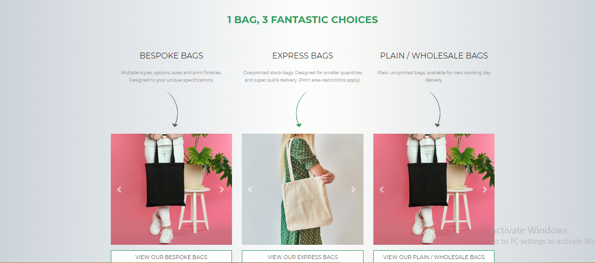

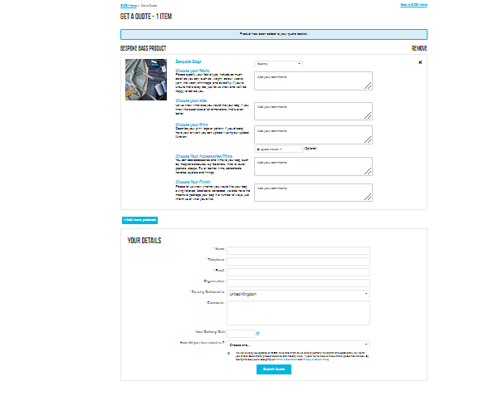

REMOVE FROM HOME PAGE???  
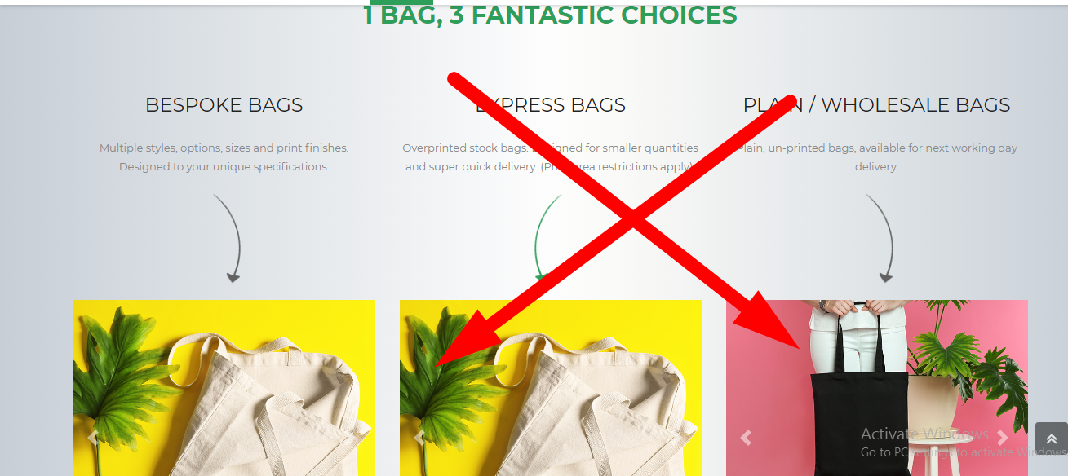

certification ka saction banega (HOME PAGE PE ADD HOGA)

1. ISO 9001:2015

2. GOTS

3. SEDEX

4. GOVT. RECOGNISED STAR EXPORT HOUSE